R Noah Padilla

11/24/2020

Dealing with Small Datasets

**Introduction**

In this exercise out goal was to use a small set of labeled data and are supposed to implement several techniques to improve the accuracy. These experiments were conducted in the Google Colab environment. The methods performed are shown below. 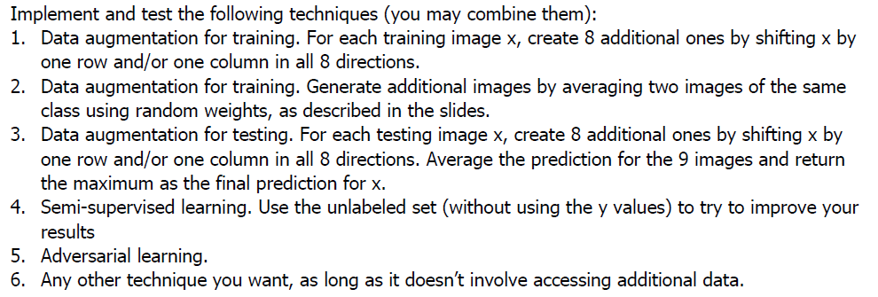

**Results**

I used the base code as a reference for each experiment and only considered that last 5/20 epochs. The base results and methods (1-6) are shown below.

**Base Results**

|  |  |  |
| --- | --- | --- |
| **EPOCH** | **LOSS** | **ACCURACY** |
| 15 | .5417 | .8067 |
| 16 | .5511 | .8025 |
| 17 | .5580 | .7914 |
| 18 | .5837 | .7862 |
| 19 | .5830 | .7881 |
| 20 | .5533 | .8080 |

**# 1-SHIFTING THE IMAGES**

|  |  |  |
| --- | --- | --- |
| **EPOCH** | **LOSS** | **ACCURACY** |
| 15 | .5475 | .7968 |
| 16 | .5530 | .7895 |
| 17 | .5294 | .8065 |
| 18 | .5591 | .7894 |
| 19 | .5285 | .8065 |
| 20 | .5319 | .8107 |

**RESULTS**

With the results shown above, a little to no increase in accuracy was obtained using the shift technique.